 | 461-463 Second Street Pike  Southampton, Pa 18966  Phone:(215) 357-3621  Fax: (215)364-6184  FAHshoes@aol.com  www.fahertyshoes.com

UCBL

A UCBL (University of California Biomechanics Laboratory), is a custom molded orthosis with increased subtalar joint (STJ) control, manufactured over a positive model of the patient’s foot.
Severe Posterior Tendon Dysfunction or tear, STJ arthritis, excessive pronation, and even excessive supination are some of the common pathologies that can require the support that a UCBL can provide.

Usually, a UCBL is manufactured with a rigid material; this provides the most control of the STJ. One of the staples of a UCBL is the very deep heel cup. As with any custom molded orthosis, additional longitudinal arch, metatarsal arch, and any other type of padding or corrections can be added, including medial or lateral posting.

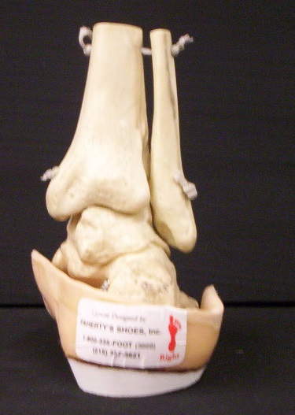A UCBL allows a greater range of motion for the ankle joint, making the UCBL not as restrictive as an AFO gauntlet. Because of the increased dorsal and plantar ankle motion, we find a greater rate of patient compliance than an AFO.

An added benefit to the increased plantarflexion and dorsiflexion is that physical therapy can be more easily performed while wearing the UCBL.

The patient’s amount of flexibility also plays a part in whether to restrict ankle motion more or less, due to how much re-alignment we can acquire. Keep in mind that when the ankle joint needs to be more restricted an AFO gauntlet is necessary.

